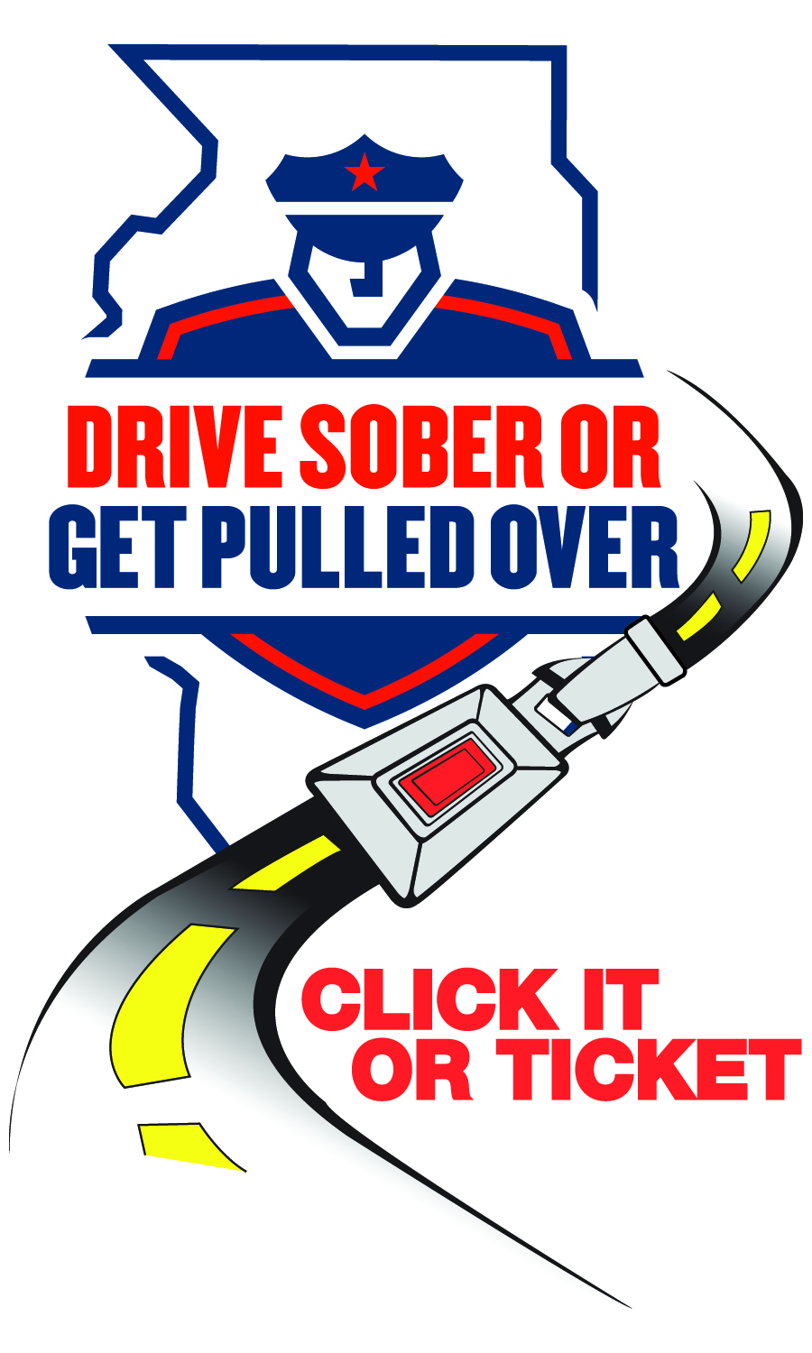

NEWS

FOR IMMEDIATE RELEASE

Date 12/20/2013

For Information Contact:
Cmdr. Robert Wright
Police@vofp.com

Holiday boozers beware: Franklin Park Police Department cracking down on drunk drivers
Drive Sober or Get Pulled Over

[Franklin Park, Illinois] – From December 20 through January 5 of the New Year, the Franklin Park Police will be out in force as part of the annual Illinois “Drive Sober or Get Pulled Over” crackdown on drunk drivers. The statewide crackdown will include high-visibility alcohol and belt enforcement throughout Franklin Park.

The statewide crackdown will also be supported by national and state paid advertising, creating a comprehensive campaign to curb drunk driving during the holiday season.

The Franklin Park Police Department said its officers will be aggressively looking for drunk drivers during the crackdown and will arrest anyone caught driving drunk. In addition, front and back seat belt law violators will be ticketed.

The Franklin Park Police Department is giving fair warning to all partygoers. “You’ll see us making lots of stops during this highly visible enforcement period and if we suspect anyone is driving while intoxicated, officers will show zero tolerance for drunk driving,” said Commander Robert Wright.

Data shows the holiday season is a particularly deadly time due to the increased number of drunk drivers on the roads, and Franklin Park is prepared to stop and arrest any drunk driver they see to keep roads safe.

“The December holiday season is the ‘most wonderful time of the year,’ and we are going to keep our roads safe for travelers heading to visit friends and family,” said Commander Wright “This holiday, we will show zero tolerance for drunk drivers on the road. If you choose to drive drunk, we will see you, we will stop you and you will be arrested.”

Being arrested for driving drunk brings a wide range of negative consequences into one’s life. Drunk drivers face jail time, loss of their driver licenses, and steep financial consequences such as higher insurance rates, attorney fees, court costs, lost time at work, and the potential loss of job. When family, friends and co-workers find out, violators also often face tremendous personal embarrassment.

“Driving drunk is simply not worth the risk. So don’t take the chance. Remember, we will be out in force and we will be watching, so ‘Drive Sober or Get Pulled Over,’” said Commander Wright.

The law enforcement crackdown is funded by federal traffic safety funds through the Illinois Department of Transportation.

