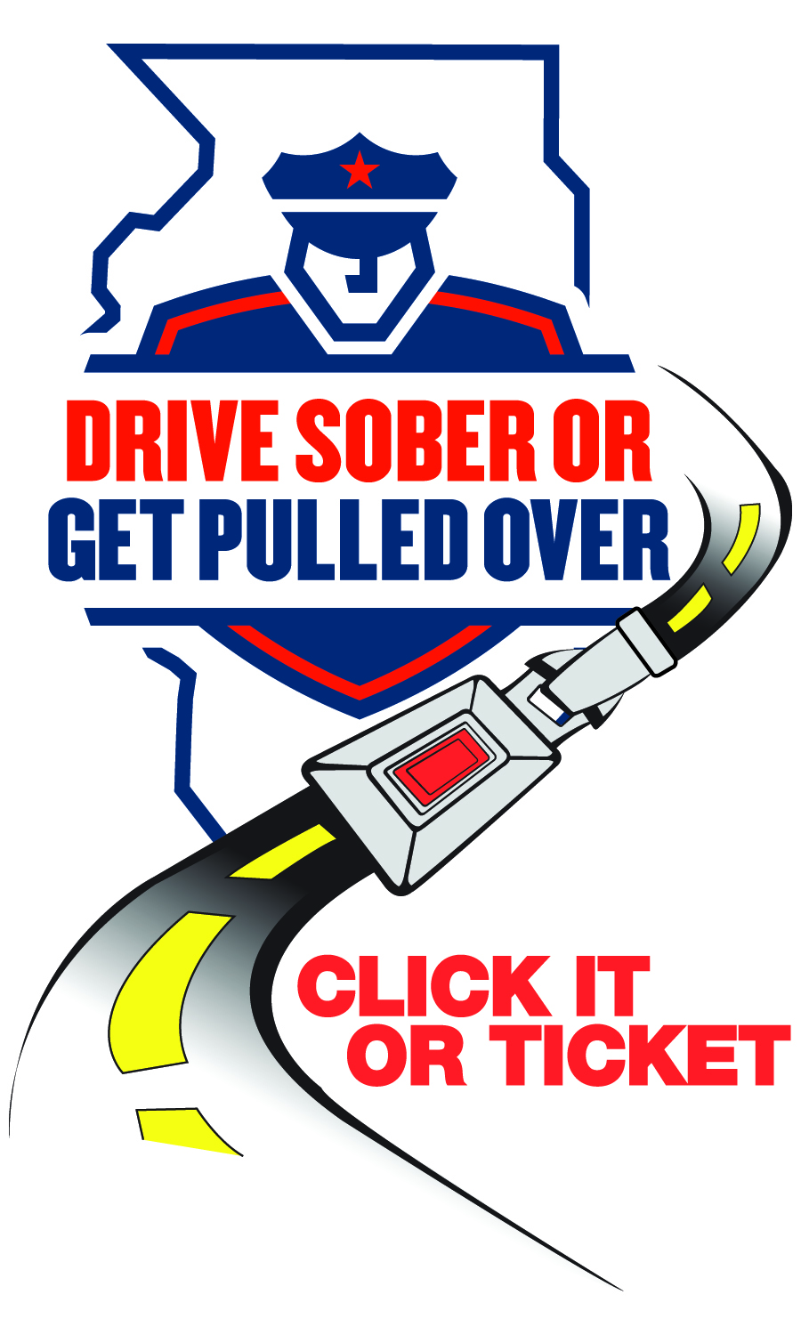

**NEWS**

**FOR IMMEDIATE RELEASE**

**September 7, 2022**

**For Information, Contact:**

**Director Michael Witz**

**mwitz@vofp.com**

**Franklin Park Police Department Announces Labor Day**

**‘Drive Sober or Get Pulled Over’ campaign results**

**(Franklin Park, IL*)*** – The Franklin Park Police Department madefour (4) DUI arrests and issued seventeen (17) seat belt citations during the recent Labor Day campaign. In addition, thirty-one (31) citations were issued for other violations including speeding and distracted driving.

“As law enforcement officers, we do our best to protect motorists, pedestrians, and other road users,” said Director Michael Witz. “While enforcement campaigns like these save lives, there is still much to be done. Please help us spread the message: Drive Sober or Get Pulled Over.”

Franklin Park Police joined forces with other law enforcement agencies and highway safety partners throughout the state for the Labor Day traffic safety campaign.

The program was made possible by federal highway safety funds administered by the Illinois Department of Transportation.

###