# Franklin Park Fire Department Residential Smoke Detector Installation

**10yeas**

## In cooperation with the Illinois Fire Safety Alliance (IFSA) and the Office of the Illinois State Fire Marshal (OSFM), the Franklin Park Fire Department is participating in the Be Alarmed! Program aimed at educating Illinois residents on fire prevention and to help ensure that there are working fire alarms installed in every Illinois home.

***Fast Fire Facts***

*3 of every 5 home fire deaths occurred in homes without (40%) or with non-working (20%) smoke alarms*

*Of the 20% of homes with present but non­ working smoke alarms, 50% had missing or disconnected batteries*

## As part of this program, the Fire Department will:

## Install NEW IO-year sealed lithium battery smoke detectors in your home, FREE!

## Explain the proper operation and maintenance of your new smoke detectors.

## Provide a home fire safety checklist and escape plan form for you and your family to review and practice.

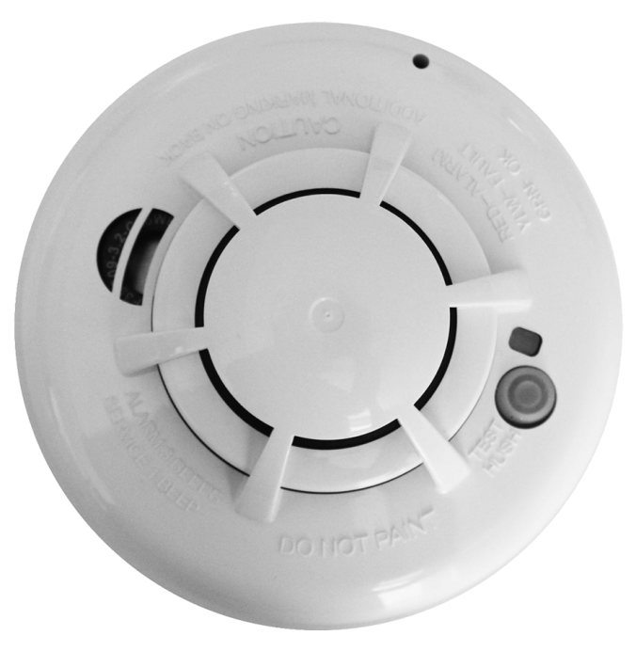



NAME: _________________________________________ ______

ADDRESS: ____________________________________________

PHONE: ________________________________________ ______

EMAIL: _______________________________________________

Franklin Park Fire Department

10001 Addison Ave.

Franklin Park, IL. 60131

(847) 678-2400

Email us: [smokedetectors@vofp.com](mailto:smokedetectors@vofp.com)

