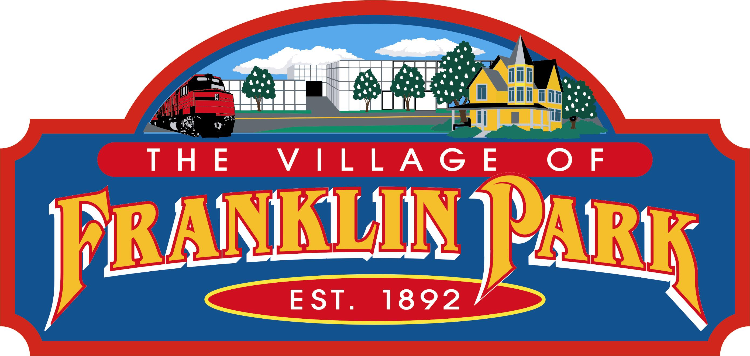 | VILLAGE OF FRANKLIN PARK
 | 9500 W. BELMONT AVENUE
 | FRANKLIN PARK, ILLINOIS 60131
President: Barrett Pedersen | TEL. 847-671-4800
Village Clerk: Roberta Johnson | URL:http://www.vofp.com
LEGAL NOTICE
PUBLIC NOTICE IS HEREBY GIVEN TO ALL RESIDENTS OF THE VILLAGE OF FRANKLIN PARK AND INTERESTED PARTIES THAT A REGULAR MEETING OF THE PRESIDENT AND BOARD OF TRUSTEES OF THE VILLAGE OF FRANKLIN PARK, COOK COUNTY, ILLINOIS WILL BE HELD AT THE HOUR OF 7:00 P.M. ON MONDAY, APRIL 6, 2020. THE MEETING WILL BE HELD AT THE VILLAGE OF FRANKLIN PARK POLICE STATION, COMMUNITY ROOM, LOCATED AT 9451 W. BELMONT AVENUE, FRANKLIN PARK, ILLINOIS 60131. THE PUBLIC IS INVITED TO ATTEND. THE FOLLOWING MATTERS MAY BE DISCUSSED OR DECIDED AT THE MEETING:

MEETING MODIFICATION DUE TO COVID-19 PANDEMIC:
Pursuant to Governor Pritzker’s Executive Order 2020-07, dated March 16, 2020, which suspends the requirement of the Illinois Open Meetings Act pertaining to in-person attendance by members of a public body during the duration of the Gubernatorial Disaster Proclamation, members of the Board of Trustees will participate in the meeting through audio access technology. The meeting room remains open to the public and the public will be allowed to address the Board of Trustees during the public comment portion of the meeting. All persons in attendance at the meeting must practice appropriate social distancing. Attendees are encouraged to leave the meeting room after making a public comment or after a matter of interest is discussed by the Board of Trustees, as Governor's Executive Order No. 2020-10, dated March 20, 2020 and CDC guidelines, require that no more than 10 people are allowed in the board room at any one time. The public is encouraged to submit written public comments in advance of the meeting to Village Clerk Roberta Johnson at RJohnson@vofp.com. A public comment submitted to the Village Clerk before 4:30 P.M. on Monday, April 6, 2020, will be read at the meeting. The Village appreciates public cooperation and understanding.
AGENDA
REGULAR MEETING OF THE BOARD OF TRUSTEES
VILLAGE OF FRANKLIN PARK, COOK COUNTY, ILLINOIS
VILLAGE OF FRANKLIN PARK POLICE STATION, COMMUNITY ROOM,
9451 BELMONT AVENUE, FRANKLIN PARK, ILLINOIS 60131
MONDAY, APRIL 06, 2020
7:00 P.M.

PLEDGE OF ALLEGIANCE

CALL TO ORDER
- ROLL CALL; ESTABLISHMENT OF QUORUM
- PUBLIC COMMENTS (Limit to 2 minutes per speaker, Ordinance 1415-G-43)

- COMMITTEE REPORTS
    - Finance and Special Events

Mr. Johnson, Chair
Mr. Hagerstrom and Mr. Ruhl, Co-Chair

    - Water and Sewer
Ms. Avitia, Chair
Ms. Special and Mr. Ybarra, Co-Chair
    - Police and Fire

Mr. Ruhl, Chair
Mr. Ybarra and Mr. Johnson, Co-Chair
4. Streets, Alleys and Fleet Maintenance

Mr. Ybarra, Chair
Mr. Hagerstrom and Mr. Ruhl, Co-Chair
5. Property, Planning, Zoning and Building

Ms. Special, Chair
Mr. Johnson and Ms. Avitia, Co-Chair

6. Health, Human Resources, Sustainable Practices and Senior Services

Mr. Hagerstrom, Chair
Ms. Special and Ms. Avitia, Co-Chair

STAFF REPORTS AND COMMENTS; DISCUSSION ON AGENDA ITEMS

CONSENT AGENDA
(Items on the Consent Agenda will be enacted or approved by a single motion or omnibus vote. There will be no separate discussion on these items unless so requested by a member of the Village Board, in which case that item will be removed from the Consent Agenda and considered in the normal sequence of the Agenda.)

1. APPROVAL OF THE MINUTES FROM:
(a) REGULAR MEETING OF THE PRESIDENT AND BOARD OF
TRUSTEES HELD ON MONDAY, MARCH 16, 2020

- APPROVAL OF VOUCHER EXPENDITURES LIST IN THE AMOUNT OF $2,102,000.91

- ORDINANCE NO. 1920 VC
AN ORDINANCE AMENDING SECTION 6-6F-8 OF CHAPTER SIX
OF TITLE SIX OF THE VILLAGE CODE OF THE VILLAGE OF FRANKLIN PARK, COOK COUNTY, ILLINOIS TO ELIMINATE THE HANDICAPPED RESERVED PARKING SPACE AT 3445 HAWTHORNE AVENUE

- ORDINANCE NO. 1920 VC
AN ORDINANCE AMENDING TITLE 8 OF THE VILLAGE CODE OF
THE VILLAGE OF FRANKLIN PARK, COOK COUNTY, ILLINOIS
(INTERNATIONAL BUILDING CODE)

- ORDINANCE NO. 1920 VC
AN ORDINANCE AMENDING TITLE 8 OF THE VILLAGE CODE OF
THE VILLAGE OF FRANKLIN PARK, COOK COUNTY, ILLINOIS
(NFPA 70 NATIONAL ELECTRICAL CODE)

- ORDINANCE NO. 1920 VC
AN ORDINANCE AMENDING TITLE 8 OF THE VILLAGE CODE OF
THE VILLAGE OF FRANKLIN PARK, COOK COUNTY, ILLINOIS
(INTERNATIONAL FIRE CODE)

- ORDINANCE NO. 1920 VC
AN ORDINANCE AMENDING TITLE 8 OF THE VILLAGE CODE OF
THE VILLAGE OF FRANKLIN PARK, COOK COUNTY, ILLINOIS
(INTERNATIONAL FUEL GAS CODE)

- ORDINANCE NO. 1920 VC
AN ORDINANCE AMENDING TITLE 8 OF THE VILLAGE CODE OF
THE VILLAGE OF FRANKLIN PARK, COOK COUNTY, ILLINOIS
(INTERNATIONAL MECHANICAL CODE)

- ORDINANCE NO. 1920 VC
AN ORDINANCE AMENDING TITLE 8 OF THE VILLAGE CODE OF
THE VILLAGE OF FRANKLIN PARK, COOK COUNTY, ILLINOIS
(INTERNATIONAL PROPERTY MAINTENANCE CODE)

- ORDINANCE NO. 1920 VC
AN ORDINANCE AMENDING TITLE 8 OF THE VILLAGE CODE OF
THE VILLAGE OF FRANKLIN PARK, COOK COUNTY, ILLINOIS
(INTERNATIONAL RESIDENTIAL CODE)

- ORDINANCE NO. 1920 VC
AN ORDINANCE AMENDING TITLE 8 OF THE VILLAGE CODE OF
THE VILLAGE OF FRANKLIN PARK, COOK COUNTY, ILLINOIS
(ILLINOIS ENERGY CONSERVATION CODE)

- ORDINANCE NO. 1920 G
AN ORDINANCE OF THE VILLAGE OF FRANKLIN PARK, COOK COUNTY, ILLINOIS RATIFYING AND APPROVING A REVISED INTERGOVERNMENTAL AGREEMENT BETWEEN THE ILLINOIS DEPARTMENT OF HEALTHCARE AND FAMILY SERVICES FOR PARTICIPATION IN THE GROUND EMERGENCY MEDICAL TRANSPORTATION PROGRAM

- ORDINANCE NO. 1920 G
AN ORDINANCE AUTHORIZING AND APPROVING A PLAT OF VACATION IN RELATION TO A CERTAIN RIGHT OF WAY LOCATED GENERALLY THROUGH 9600 FRANKLIN AVENUE WITHIN THE CORPORATE BOUNDARIES OF THE VILLAGE OF FRANKLIN PARK, COOK COUNTY, ILLINOIS

- ORDINANCE NO. 1920 G
AN ORDINANCE OF THE VILLAGE OF FRANKLIN PARK, COOK COUNTY, ILLINOIS CONCERNING A DECLARATION OF A STATE OF EMERGENCY

- ORDINANCE NO. 1920 Z
AN ORDINANCE APPROVING A PRELIMINARY PLAT OF CONSOLIDATION FOR CERTAIN PARCELS OF PROPERTY COMMONLY KNOWN AS 9600 FRANKLIN AVENUE, FRANKLIN PARK, COOK COUNTY, ILLINOIS

- Motion to Approve Building Department Permit and Code Enforcement Software Licenses, Maintenance and Support Agreement for a Five Year Period from Accela, Incorporated, San Ramon, California in an amount not to exceed $209,831.67 Payable in Five Annual Installments, to Ensure the Health, Safety and Welfare of the Residents and Authorize the Officers and Officials of the Village to Undertake Such Action to Effectuate Same

- MOTION TO APPROVE THE SALVATION ARMY REQUEST TO CONDUCT THEIR ANNUAL DONUT DAY ON FRIDAY, JUNE 5, 2020 and their annual RED KETTLE CAMPAIGN MONDAY, NOVEMBER 1, 2020 TO SATURDAY, DECEMBER 24, 2020

  - NEW BUSINESS

  - APPOINTMENTS/SWEARING IN

  - COMMENTS FROM THE CLERK

  - COMMENTS FROM THE PRESIDENT
  - CLOSED/EXECUTIVE SESSION
1. Purchase or Lease of Real Property, 5 ILCS 120/2(c)(5),
2. Setting of a Price for the Sale or Lease of Property, 5 ILCS 120/2(c)(6)
3. Pending Litigation, 5 ILCS 120/2(c)(11)
4. Probable or Imminent Litigation, 5 ILCS 120/2(c)(11)
5. Salary Schedules for one or More Classes of Employees 5 ILCS 120/2(c)(2)
6. Employment, Compensation, Discipline, Performance or Dismissal of Certain
Employees 5 ILCS 120/2(c)(1)
7. Collective Bargaining Negotiations Matters 5 ILCS 120/2(c)(2)
8. Discussion of Minutes of Meetings Closed under the Open Meetings Act,
5 ILCS 120/2(c)(21)
9. Security Procedures, 5 ILCS 120/2(c)(8)

- ADJOURNMENT

LEGAL NOTICE AND AGENDA POSTED IN THE FRANKLIN PARK MUNICIPAL BUILDING (VILLAGE HALL) AND THE POLICE STATION ON FRIDAY,
APRIL 03, 2020.

/s/ ROBERTA JOHNSON, VILLAGE CLERK, VILLAGE OF FRANKLIN PARK

