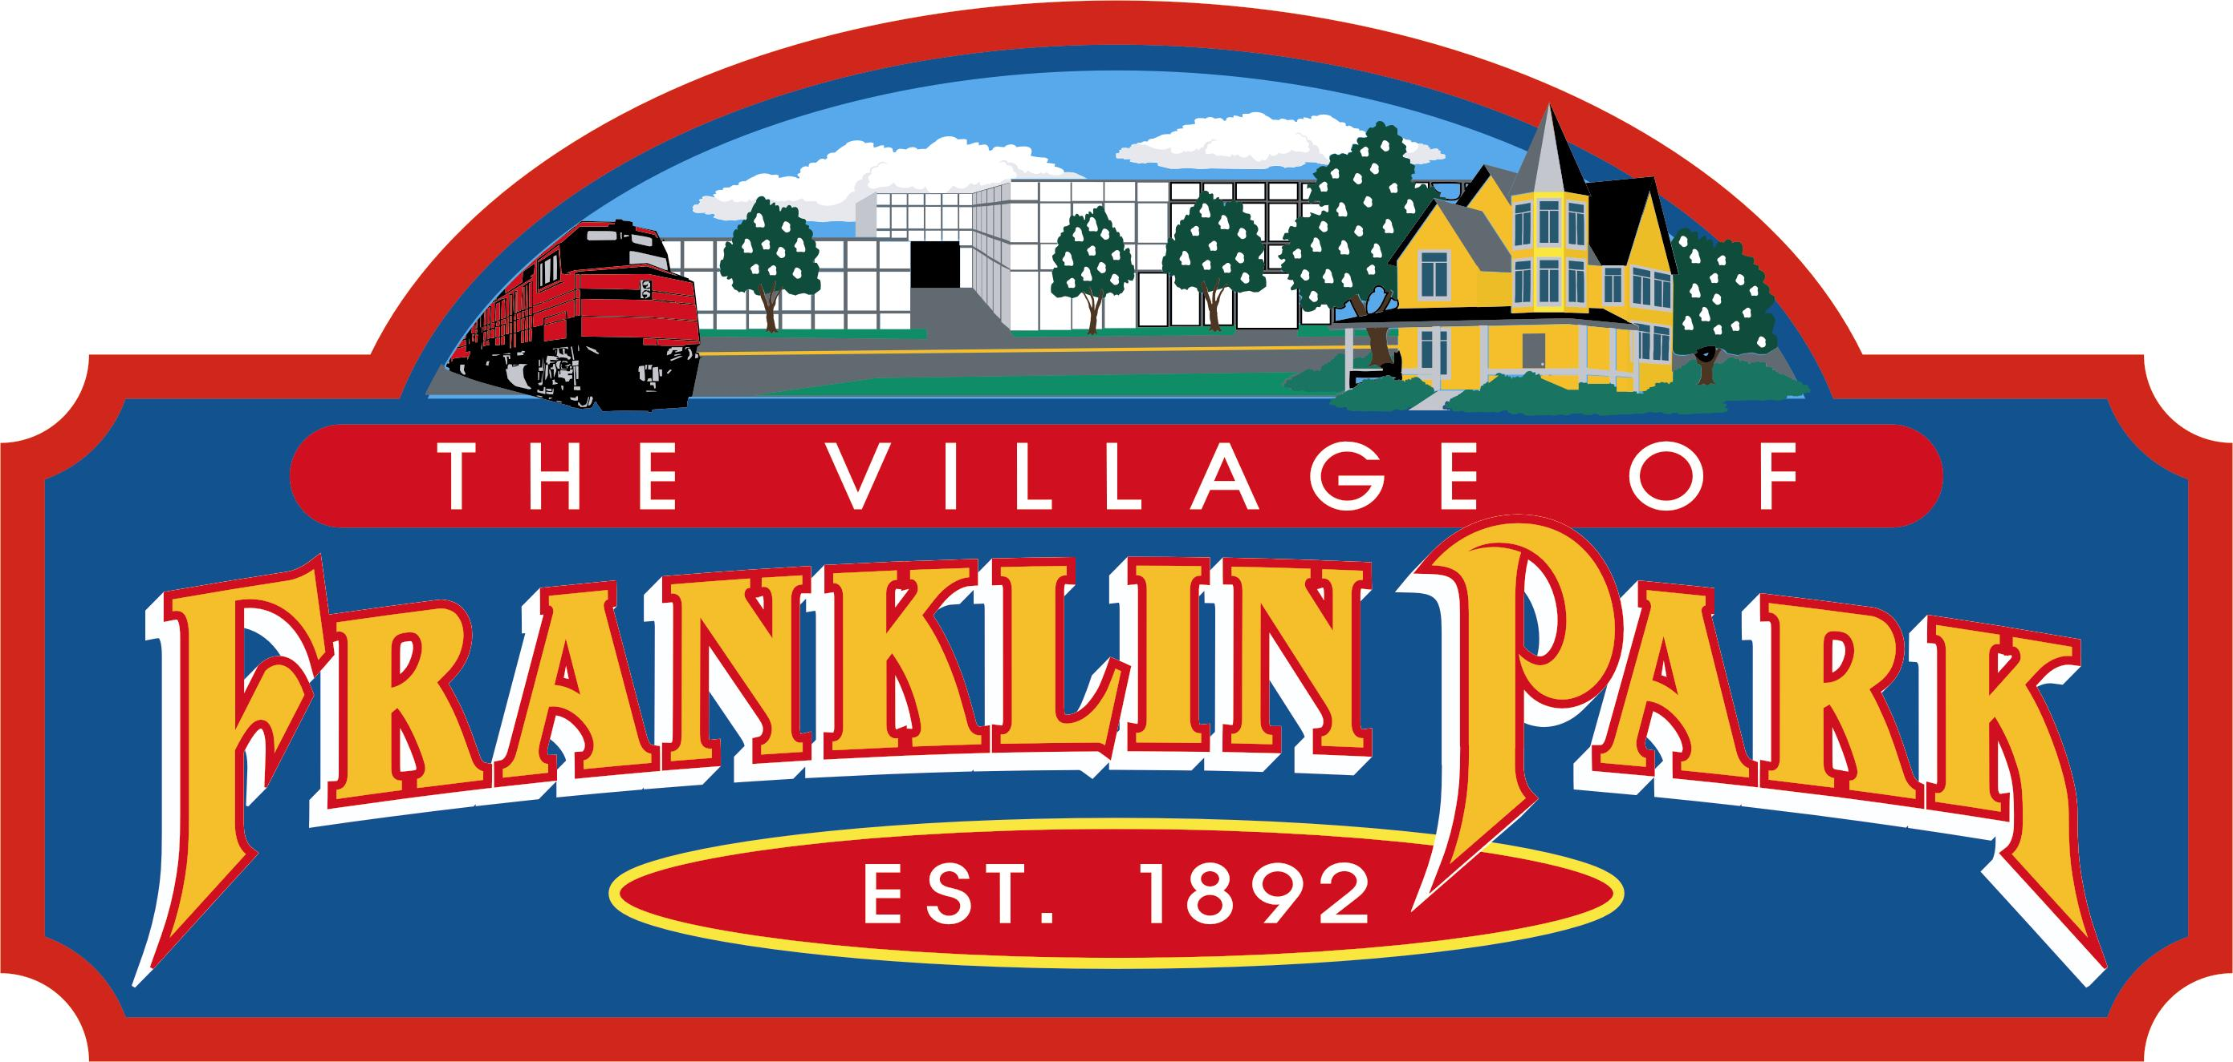 | VILLAGE OF FRANKLIN PARK
 | 9500 W. BELMONT AVENUE
 | FRANKLIN PARK, ILLINOIS 60131
President: Barrett Pedersen | TEL. 847-671-4800
Village Clerk: Tommy Thomson | URL:http://www.vofp.com
LEGAL NOTICE
PUBLIC NOTICE IS HEREBY GIVEN TO ALL RESIDENTS OF THE VILLAGE OF FRANKLIN PARK AND INTERESTED PARTIES THAT A REGULAR MEETING OF THE PRESIDENT AND BOARD OF TRUSTEES OF THE VILLAGE OF FRANKLIN PARK, COOK COUNTY, ILLINOIS WILL BE HELD AT THE HOUR OF 7:00 P.M. ON MONDAY, DECEMBER 21, 2015. THE MEETING WILL BE HELD AT THE VILLAGE OF FRANKLIN PARK POLICE STATION, COMMUNITY ROOM, LOCATED AT 9451 W. BELMONT AVENUE, FRANKLIN PARK, ILLINOIS 60131. THE PUBLIC IS INVITED TO ATTEND. THE FOLLOWING MATTERS MAY BE DISCUSSED OR DECIDED AT THE MEETING:

AGENDA
REGULAR MEETING OF THE BOARD OF TRUSTEES
VILLAGE OF FRANKLIN PARK, COOK COUNTY, ILLINOIS
VILLAGE OF FRANKLIN PARK POLICE STATION, COMMUNITY ROOM,
9451 BELMONT AVENUE, FRANKLIN PARK, ILLINOIS 60131
MONDAY, DECEMBER 21, 2015
7:00 P.M.

PLEDGE OF ALLEGIANCE

CALL TO ORDER
- ROLL CALL; ESTABLISHMENT OF QUORUM
- SWEARING IN OF JUSTIN LUCADELLO AS FRANKLIN PARK FIREFIGHER
- PUBLIC COMMENTS (Limit to 2 minutes per speaker, Ordinance 1415-G-43)
- COMMITTEE REPORTS
  - Finance and Special Events

Mr. Johnson, Chair
Ms. McLean, Mr. Ruhl, Co-Chair

  - Water and Sewer
Mr. Caporusso, Chair
Ms. Special and Mr. Ybarra, Co-Chair

- Police and Fire

Mr. Ruhl, Chair
Mr. Ybarra and Mr. Johnson, Co-Chair
4. Streets, Alleys and Fleet Maintenance

Mr. Ybarra, Chair
Mr. Caporusso and Mr. Ruhl, Co-Chair
5. Property, Planning, Zoning and Building

Ms. Special, Chair
Mr. Johnson and Ms. McLean, Co-Chair

  - Health, Human Resources, Sustainable Practices and Senior Services

Ms. McLean, Chair
Ms. Special and Mr. Caporusso, Co-Chair

VII. STAFF REPORTS AND COMMENTS; DISCUSSION ON AGENDA ITEMS

VIII. CONSENT AGENDA
(Items on the Consent Agenda will be enacted or approved by a single motion or omnibus vote. There will be no separate discussion on these items unless so requested by a member of the Village Board, in which case that item will be removed from the Consent Agenda and considered in the normal sequence of the Agenda.)

1. APPROVAL OF THE MINUTES FROM:
(a) REGULAR MEETING OF THE PRESIDENT AND BOARD OF TRUSTEES
HELD ON MONDAY, DECEMBER 07, 2015
(b) COMMITTEE OF THE WHOLE MEETING HELD ON MONDAY,
DECEMBER 14, 2015
- APPROVAL OF VOUCHER EXPENDITURES LIST IN THE AMOUNT OF $2,061,800.42
- ORDINANCE NO. 1516 VC
AN ORDINANCE AMENDING SECTION 6-6F-13 OF CHAPTER SIX OF TITLE SIX OF THE VILLAGE CODE OF THE VILLAGE OF FRANKLIN PARK, COOK COUNTY, ILLINOIS AMENDING THE OVERNIGHT RESIDENTIAL PERMIT PARKING PLACARD FEE SCHEDULE
- ORDINANCE NO. 1516 G
AN ORDINANCE OF THE VILLAGE OF FRANKLIN PARK, COOK COUNTY, ILLINOIS AMENDING ORDINANCE NUMBER 1516-G-37 (AMEND SALARY SCHEDULE ORDINANCE)
- ORDINANCE NO. 1516 G
AN ORDINANCE APPROVING A CONSULTING AND SERVICES AGREEMENT BY AND BETWEEN THE JORDAN GROUP AND THE VILLAGE OF FRANKLIN PARK, COOK COUNTY, ILLINOIS
- ORDINANCE NO. 1516 G
AN ORDINANCE AUTHORIZING THE SALE AT AUCTION BY OBENAUF AUCTION SERVICE OF CERTAIN SURPLUS VEHICLES AND PROPERTY OWNED BY THE VILLAGE OF FRANKLIN PARK, COOK COUNTY, ILLINOIS
- ORDINANCE NO. 1516 G
THE ANNUAL TAX LEVY ORDINANCE OF THE VILLAGE OF FRANKLIN PARK, COOK COUNTY, ILLINOIS, FOR THE FISCAL YEAR BEGINNING
MAY 1, 2015 AND ENDING APRIL 30, 2016
- ORDINANCE NO. 1516 G
AN ORDINANCE OF THE VILLAGE OF FRANKLIN PARK, COOK COUNTY, ILLINOIS, AUTHORIZING AND APPROVING AN INTERGOVERNMENTAL AGREEMENT BETWEEN THE VILLAGE OF FRANKLIN PARK AND FRANKLIN PARK SCHOOL DISTRICT NO. 84
- ORDINANCE NO. 1516 Z
AN ORDINANCE OF THE VILLAGE OF FRANKLIN PARK, COOK COUNTY, ILLINOIS, GRANTING A CONDITIONAL USE TO ALLOW A “WOODWORKING AND WOOD PRODUCTS” USE IN THE I-1 RESTRICTED INDUSTRIAL DISTRICT (ZBA 15-16: 9400 ROBINSON AVENUE)
- ORDINANCE NO. 1516 Z
AN ORDINANCE OF THE VILLAGE OF FRANKLIN PARK, COOK COUNTY, ILLINOIS, GRANTING A CONDITIONAL USE TO ALLOW A “RESTAURANT” USE WITHIN THE C-3 GENERAL COMMERCIAL DISTRICT
(ZBA 15-17: 10150 GRAND AVENUE)

- ORDINANCE NO. 1516 Z
AN ORDINANCE OF THE VILLAGE OF FRANKLIN PARK, COOK COUNTY, ILLINOIS, GRANTING A CONDITIONAL USE TO ALLOW A “GARAGES FOR STORAGE, REPAIR AND SERVCING OF MOTOR VEHICLES, INCLUDING BODY REPAIR, PAINTING AND ENGINE REBUILDING” IN THE
I-2 INDUSTRIAL DISTRICT (ZBA 15-18: 11127 FRANKLIN AVENUE
- MOTION TO APPROVE ST. MARIA GORETTI CATHOLIC GRADE SCHOOL REQUEST TO HOLD A 5K RUN ON SATURDAY, MAY 21, 2016, AT 8:00 A.M.

IX. NEW BUSINESS
X. APPOINTMENTS/SWEARING IN

XI. COMMENTS FROM THE CLERK
XII. COMMENTS FROM THE PRESIDENT
XIII. CLOSED/EXECUTIVE SESSION
1. Purchase or Lease of Real Property, 5 ILCS 120/2(c)(5),
2. Setting of a Price for the Sale or Lease of Property, 5 ILCS 120/2(c)(6)
3. Pending Litigation, 5 ILCS 120/2(c)(11)
4. Probable or Imminent Litigation, 5 ILC 120/2(c)(11)
5 Salary Schedules for one or More Classes of Employees 5 ILCS 120/2(c)(2)
6. Employment, Compensation, Discipline, Performance or Dismissal of Certain
Employees 5 ILCS 120/2(c)(1)
7. Collective Bargaining Negotiations Matters 5 ILCS 120/2(c)(2)
8. Discussion of Minutes of Meetings Closed under the Open Meetings Act,
5 ILCS 120/2(c)(21)
9. Security Procedures, 5 ILCS 120/2(c)(8)

XIV. ADJOURNMENT

LEGAL NOTICE AND AGENDA POSTED IN THE FRANKLIN PARK MUNICIPAL BUILDING (VILLAGE HALL) AND THE POLICE STATION ON FRIDAY,
DECEMBER 18, 2015.

/s/ TOMMY THOMSON, VILLAGE CLERK
VILLAGE OF FRANKLIN PARK

