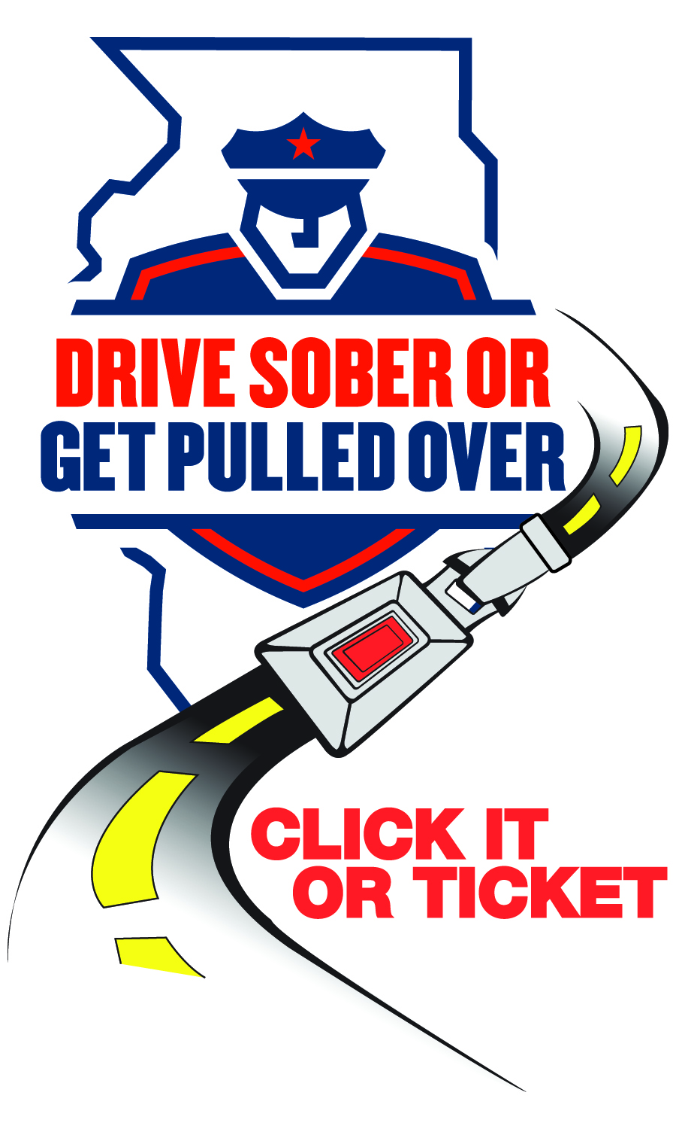 **December 20**

**Village Hall will close at 3 PM on December 23 and will be closed on December 24 and 25 for Christmas.**

**December 26**

**Passport Service Available at the Library**

The Clerk’s Office will provide passport service at the Franklin Park Library by appointment only from 10 AM to 3 PM on the following Saturday’s:

January 25, February 22, and March 22.

On-site photo services will be available. To schedule your appointment or if you have a question, call the Clerk’s Office at 847-671-8242.

**December 29**

**Village Hall will close at 3 PM on January 31 HOLIDAY and will be closed on January 1 for New Year.**

**NEWS**

**FOR IMMEDIATE RELEASE**

December 4, 2024

**For Information, Contact:**

Director Michael Witz

[mwitz@vofp.com](mailto:mwitz@vofp.com)

**Franklin Park Police Department releases Thanksgiving enforcement numbers**

**Franklin Park, IL** – The Franklin Park Police Department conducted a traffic safety campaign from November 22 to December 2 aimed at reminding motorists to buckle up and drive sober. The “Click It or Ticket” and “Drive Sober or Get Pulled Over” mobilization was carried out by Franklin Park Police in collaboration with state and local law enforcement agencies across Illinois to reduce fatalities.

During the campaign, Franklin Park Police Department reported the following enforcement outcomes:

* Three (3) speeding citations.
* Thirty-Five (35) occupant restraint citations.
* Three (3) electronic device use citations.
* Seven (7) DUI arrests.
* Fifty-Five (55) other traffic citations.
* Six (6) traffic arrests.
* Two (2) criminal arrests.

“We issue tickets to remind drivers and passengers that seat belt use isn’t a suggestion, it’s the law,” said Director Witz. “This year’s campaign was successful in grabbing people’s attention with highly visible enforcement methods. As always, our goal is a safe community with safe drivers.”

The Thanksgiving enforcement effort was made possible by federal traffic safety funds administered by the Illinois Department of Transportation and is part of the statewide “Drive Sober or Get Pulled Over” and “Click It or Ticket” campaigns.

###