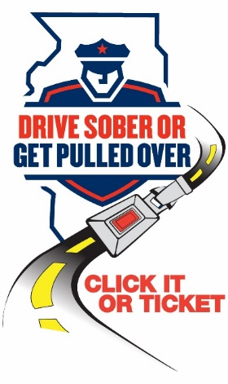

**NEWS**

**FOR IMMEDIATE RELEASE**

March 4, 2024

**For Information, Contact:**

Director Michael Witz

[mwitz@vofp.com](mailto:mwitz@vofp.com)

**This St. Patrick’s Day, plan before you party!**

***Remember: Drive Sober or Get Pulled Over***

**(*Franklin Park, IL)*** – St. Patrick’s Day is just around the corner, and many Illinoisans will be celebrating with parades and parties featuring green beer and cocktails. To remind motorists of the dangers of drunk driving and to help keep our streets safe, the Franklin Park Police Department is teaming up with the Illinois State Police and Illinois Department of Transportation for a stepped-up traffic safety campaign.

“Because St. Patrick’s Day falls on a Sunday this year, we anticipate that alcohol consumption will increase both that day and throughout the weekend,” said Director Michael Witz. “We ask everyone to celebrate responsibly, starting with a plan for a sober ride home before you leave the house.”

St. Patrick’s Day can be a dangerous one on America’s roads due to increased alcohol consumption and drunk driving. There were 272 lives lost in drunk-driving crashes over the St. Patrick’s Day holiday between 2017 and 2021.

In addition to looking for alcohol- and cannabis-impaired drivers, the Franklin Park Police Department will be stepping up seat belt enforcement, particularly at night when seat belt usage rates are lowest. Speeding, distracted driving and all traffic laws will be strictly enforced.

Whether you’re attending a party, hosting friends, or going out to a bar, keep safety at the forefront of your day and night. When it’s time to leave, make sure your designated driver is sober. Remember that walking impaired can also be dangerous, so designate a sober friend to walk home with you. Designated drivers: Be alert for impaired walkers who may not obey street signs.

Other important tips:

* Drunk or high, it doesn’t matter. It is never okay to drive impaired. Designate a sober driver or plan to use public transportation or a ride service to get home safely.
* Use your community’s sober ride program
* If you see an impaired driver on the road, contact law enforcement.
* Have a friend who is about to drive impaired? Take the keys away and plan to get your friend home safely.
* Always buckle up!

The St. Patrick’s Day enforcement campaign is funded by federal traffic safety funds from the National Highway Traffic Safety Administration and administered by IDOT.

###