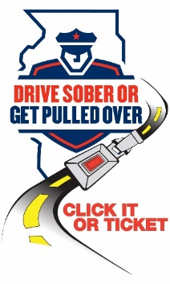

**NEWS**

**FOR IMMEDIATE RELEASE For Information, Contact:**

June 19, 2024Director Michael Witz

[mwitz@vofp.com](mailto:mwitz@vofp.com)

**Franklin Park Police Department Increases Traffic Enforcement for July Fourth Celebrations**

*Drive Sober or Get Pulled Over, Drive High Get a DUI*

***(Franklin Park, Illinois)*** – As Independence Day approaches, Franklin Park Police are gearing up for increased traffic enforcement to ensure the safety of all residents and motorists. From June 21 through the early-morning hours of July 8, our officers will be working tirelessly to keep impaired drivers off the road and ticketing unbuckled motorists.

“It’s a straightforward message: If you're behind the wheel, stay sober. Don’t drink, use marijuana, or consume any other impairing substances before or when driving,” said Director Witz. “Our officers will be on duty around the clock, dedicated to enforcing traffic laws and, most importantly, saving lives.”

Driving under the influence not only poses a grave risk to oneself but also endangers passengers and fellow road users. The financial and human costs of a DUI are immeasurable. The decision to avoid driving impaired is simple and could save lives.

Franklin Park Police Department is collaborating with the Illinois State Police and over 200 local police and sheriffs’ departments in this unified effort to enhance statewide enforcement during this period.

To ensure a fun and safe holiday celebration, we urge everyone to follow these tips:

* Designate a sober driver before heading out.
* Prevent friends and family members from driving under the influence.
* If you find yourself impaired, use safe alternatives such as taxis, public transit and ride-sharing apps, or contact a sober friend or family member for a ride.
* Use designated driver programs available in your community.
* Report suspected drunk drivers promptly to law enforcement by pulling over and dialing 911.
* Ensure that all passengers in your vehicle buckle up. It’s not only the law, but also a crucial defense against impaired drivers.

The traffic safety enforcement effort, including the “Drive Sober or Get Pulled Over,” “Drive High Get a DUI,” and “Click It or Ticket” programs, is made possible through federal highway safety funds administered by the Illinois Department of Transportation. These efforts are complemented by IDOT’s “It’s Not a Game” media campaign, which emphasizes the serious consequences of impaired driving and other unsafe driving behaviors.

##