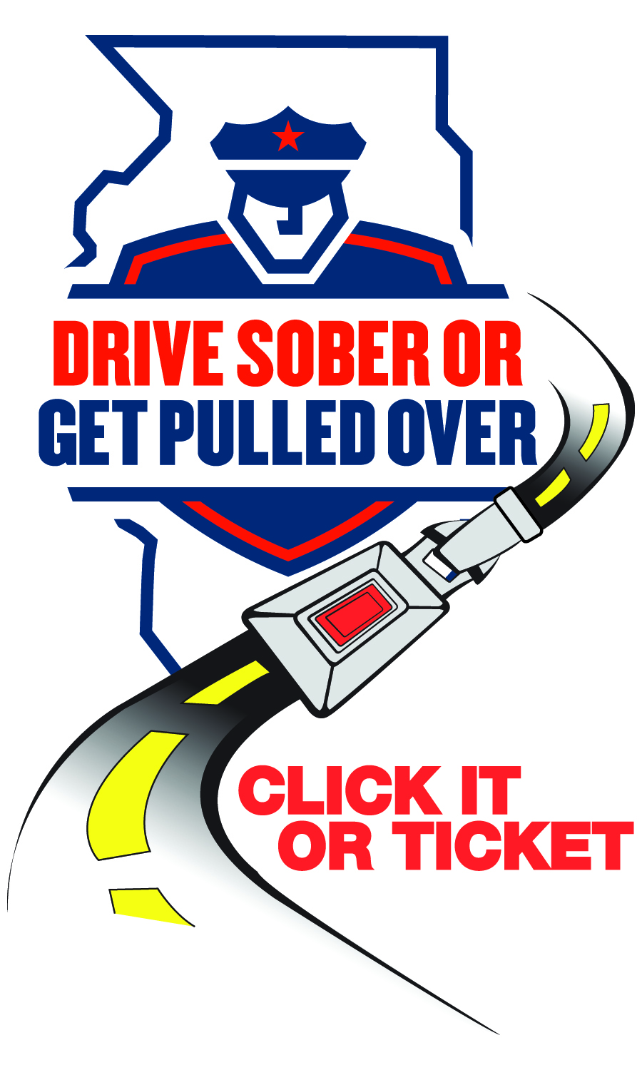

**NEWS**

**FOR IMMEDIATE RELEASE**

December 12, 2024

**For Information, Contact:**

Director Michael Witz

[mwitz@vofp.com](mailto:mwitz@vofp.com)

**Holiday cheers, Not Tears: ‘Drive Sober or Get Pulled Over,’**   
**‘Drive High, Get a DUI’**

**[Franklin Park, IL]** – With the holiday season just around the corner, the Franklin Park Police Department has joined forces with the Illinois Department of Transportation for the “Drive Sober or Get Pulled Over” and “Drive High, Get a DUI” enforcement campaign to ensure that festive gatherings don’t end in tragedy. From Dec. 13 through Jan. 2, law enforcement agencies across Illinois will adopt a zero-tolerance policy for impaired driving to keep our roads safe.

“This season let’s make safety our shared priority,” said Director Witz. “If you plan to drink or use impairing substances, plan for a sober ride home. Driving impaired isn’t just dangerous – it’s unacceptable. We’ll be out in full force, and no excuses will be accepted.”

Franklin Park Police Department urges everyone to take the following simple steps to prevent impaired driving:

* **Plan ahead:** Designate a sober driver, use public transportation or arrange for a ride-sharing service.
* **Report dangers:** If you spot an impaired driver, pull over safely and contact the police.
* **Be a hero:** Stop a friend from driving impaired by taking their keys and helping them get home safely.
* **Buckle up:** It’s your best defense against impaired drivers.

Make this holiday season memorable for all the right reasons. Celebrate responsibly and help ensure everyone gets home safely.

This campaign is made possible through federal highway safety funds from the National Highway Traffic Safety Administration administered by IDOT.

###