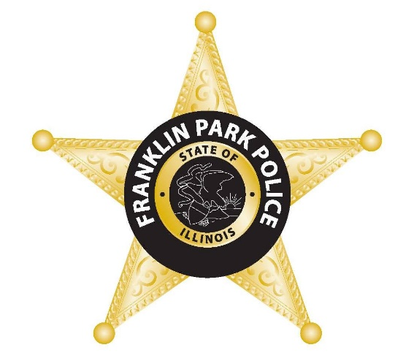
NEWS

FOR IMMEDIATE RELEASE
March 22, 2023
For Information, Contact:
Director Michael Witz
mwitz@vofp.com

The Franklin Park Police Department Announces St. Patrick’s Day
DUI Enforcement Results

(Franklin Park, IL) – The Franklin Park Police Department announced that it made six (6) DUI arrests and issued thirty-four (34) seat belt citations during the St. Patrick’s Day enforcement period. In addition to the impaired driving arrests and seat belt citations, Franklin Park Police issued nine (9) citations for speeding, four (4) citations for distracted driving, three (3) citations for driving without a valid license, forty-five (45) citations for other traffic offenses, and made three (3) arrests for violation of criminal laws.

“We strongly enforce traffic laws for one reason – to save lives,” said Director Michael Witz.

The Franklin Park Police Department joined forces with state and local law enforcement and highway safety partners in the St. Patrick’s Day enforcement campaign.

The St. Patrick’s Day enforcement campaign was funded by federal highway safety funds administered by the Illinois Department of Transportation.

###

